192.168.1.133 (Victim’s IP)
      - Malicious Server)
Source is the victim’s computer
Destination is the hosting provider
Destination Host is the domain server hosting the exploit kit.

Frame 12: a GET request was made for cb.php which is the initial Exploit Kit script.
Host want the website,just55.justhost.com but redirector to abrahamspath.org.uk.
Frame 14:
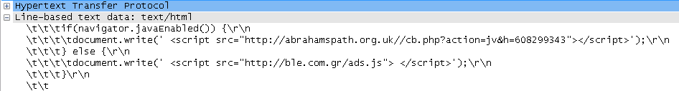

Frame 15: Java was enabled in the victim’s browser.
Frame 25: a 302 Moved Temporarily message.
a redirection occurred to criagift.com.br.
Frame 35: find criagift.com.br, follow the TCP Stream.
Frame 53: the enumeration of the victim determined that Java is on and let the malicious server know.
Frame 61: the victim’s browser performed a DNS lookup for danieldelandy.com.
Frames 69 and 70: show the download requests for two java browser exploits.
Frame 107: The java exploits were successful and the browser requested a download of rh.exe.
Frame 786: rh.exe sends a DNS lookup for uploads.boxify.me.
Frame 794: The payload rh.exe requests from the uploads.boxify.me server and is called Laine.lora.
Frame 789: the java exploits telling the malicious server that they have loaded successfully.
Frame 5145: One of the three malicious files in Laine.lora sends a POST to another malicious server.

